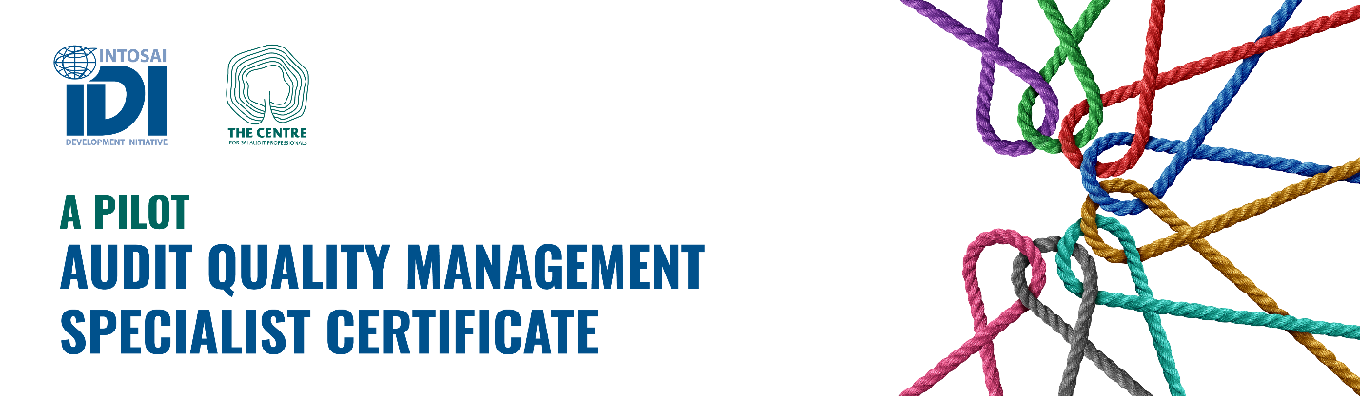Pilot of Audit Quality Management Specialist Certificate
SAI commitment and approval of nominations

Name of SAI:
Country:

In accordance with the IDI’s nomination criteria, our SAI hereby authorises the following personnel to participate in the Audit Quality Management Specialist Certificate, within the respective specialised areas:
AQMS Specialised areas | Name and other details
- Quality Risk Management
- Monitoring and Remediation (Financial Audit stream)
- Monitoring and Remediation (Performance Audit stream)
- Monitoring and Remediation (Compliance Audit stream)

This nomination will be accompanied by the nominee’s curriculum vitae.
SAI commitments
Our SAI is fully committed to providing the necessary support to the nominated personnel, ensuring they have access to sufficient time and IT resources to actively participate and engage in the initiative. Upon successful completion of the assessments and certification, these individuals will be recognised as "Certified Audit Quality Management Specialists." Our SAI will continue to support and collaborate with our certified specialists, maximising their potential in assisting our SAI to establish and implement a robust, fit-for-purpose System of Audit Quality Management, in alignment with the revised ISSAI 140.
Additionally, our SAI will actively support our certified specialists who will join the global pool under the IDI’s Shared Services arrangements, contributing to global efforts in advancing the new approach to quality management.

_______________________________
Head of SAI

Date: _________________________

